Company Name: Urbego Cybersecurity Assessment Date: February 10, 2026 Report Date: [Current Date] Prepared By: Grok Analysis (xAI) Version: 1.0 Confidential: For Internal Use Only

nist.gov
Cybersecurity Framework | NIST

Table of Contents
- Executive Summary
- Introduction to NIST CSF 2.0
- Assessment Methodology & Scoring Logic
- Overall Maturity Results
- Detailed Analysis by Function 5.1 Govern (GV) 5.2 Identify (ID) 5.3 Protect (PR) 5.4 Detect (DE) 5.5 Respond (RS) 5.6 Recover (RC)
- NIST CSF Tiers Mapping
- Prioritized Recommendations & Roadmap
- Conclusion Appendix A: Full Assessment Questions & Responses Appendix B: References
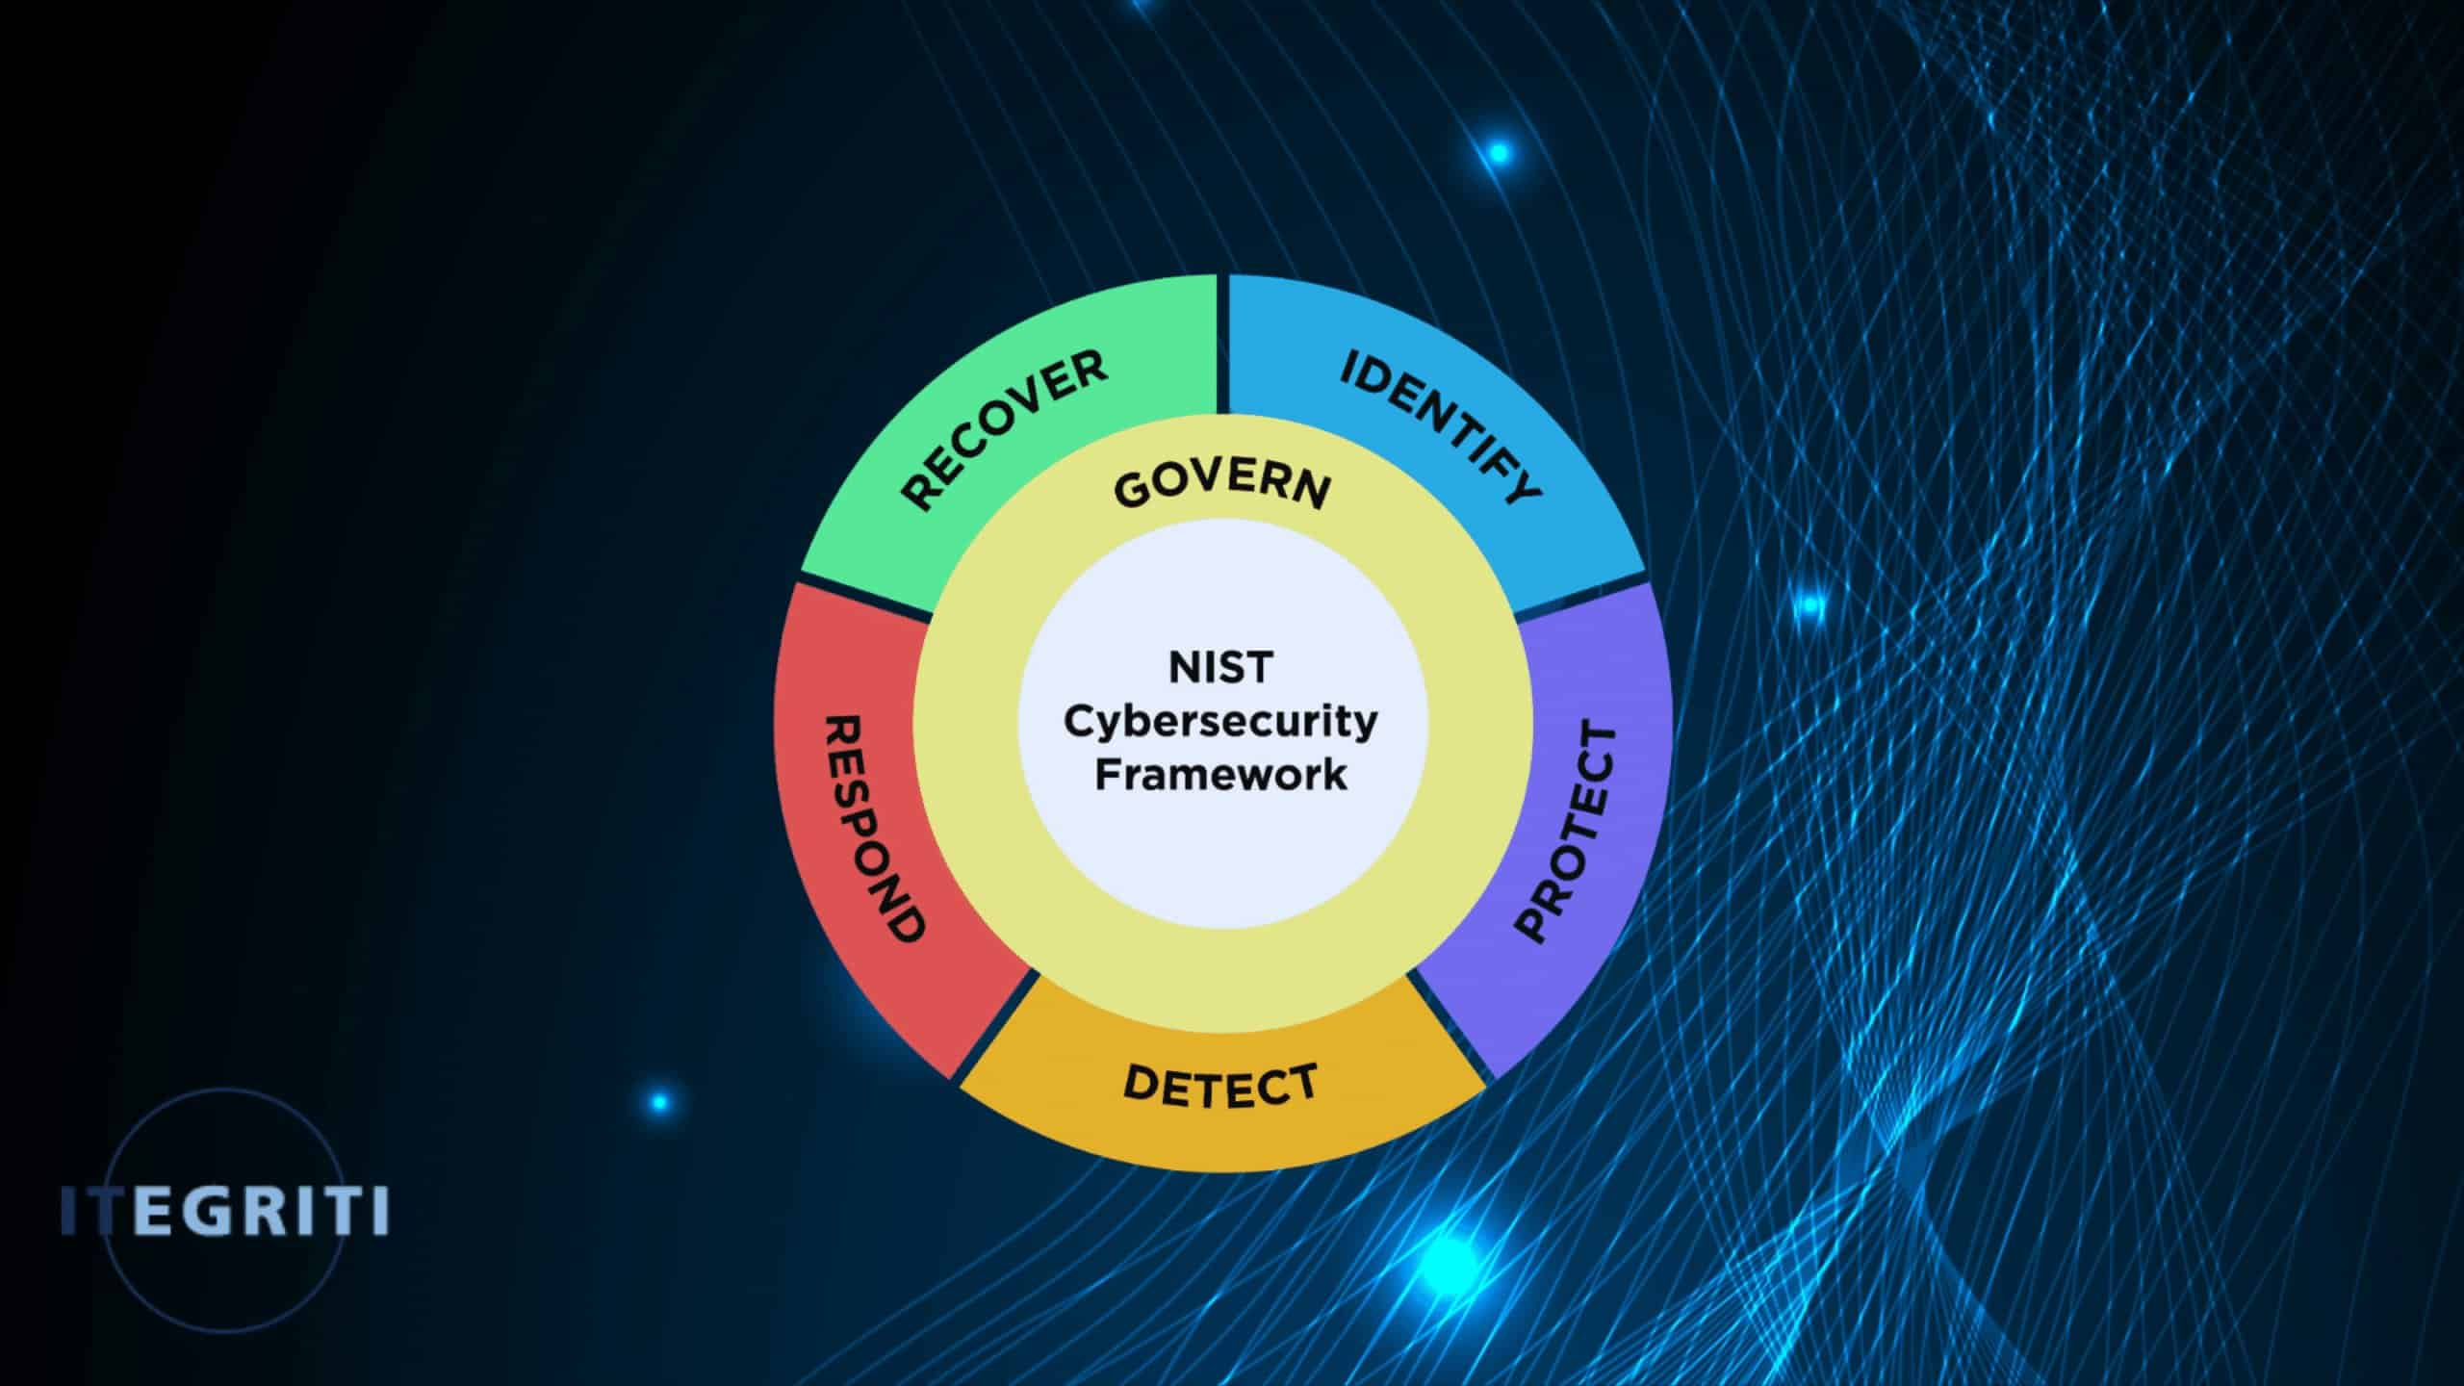
itegriti.com
What the Expanded NIST 2.0 Still Holds for Critical Infrastructure

1. Executive Summary
Urbego Cybersecurity completed a self-assessment against NIST CSF 2.0 (February 2024). The framework's six functions help manage cybersecurity risks flexibly for any organization.
88 applicable questions (excluding Not Applicable, mainly supply chain) were scored on a 0-3 scale.
Overall Maturity: 53% (140/264 points) – average 1.59/3.00 Strongest Functions: Identify (55.6%), Govern (55.1%) Weakest Functions: Protect (49.1%), Detect (50.0%)
Key Strengths:
- Strong asset management, data protection at rest, physical security, threat intelligence.
- Leadership oversight and risk appetite definition.
Critical Gaps:
- No formal policies, roles/responsibilities, resource allocation.
- Missing incident response plans, logging, monitoring, configuration management.
NIST Tiers Alignment: Primarily Tier 2 (Risk Informed), approaching Tier 3 in asset identification.
Target: Reach Tier 3 (Repeatable) in 18 months via prioritized actions.
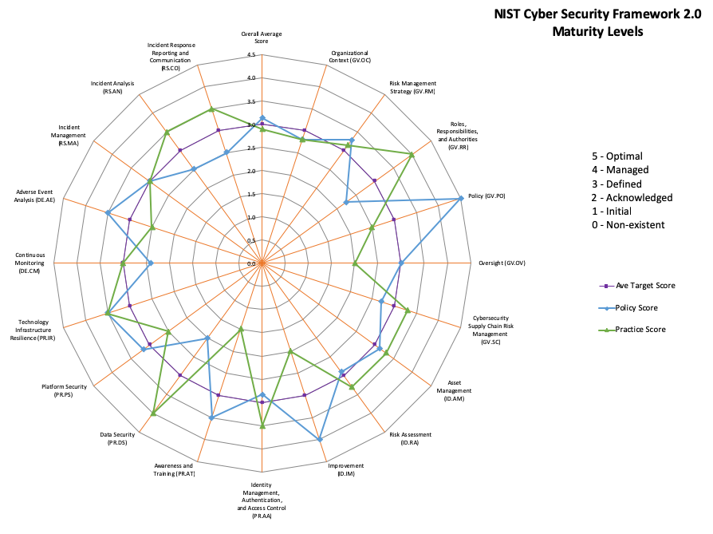
johnmasserini.com
NIST CSF 2.0 Tool Download Page | Chronicles of a CISO

2. Introduction to NIST CSF 2.0
NIST CSF 2.0 provides a taxonomy of outcomes for managing cybersecurity risks. It applies to all organizations and emphasizes governance and supply chain risks.
Core Structure (Six Functions):
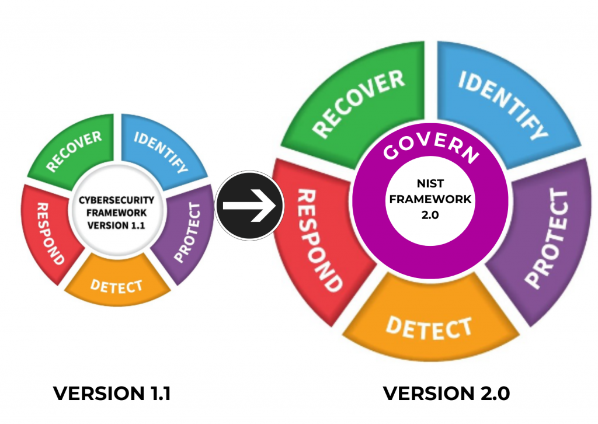
clearinfosec.com
NIST Cybersecurity Framework 2.0: A Comprehensive Guide to Enhanced Digital Defense - Clear Infosec
This report establishes a Current Profile, highlights gaps, and recommends improvements aligned with NIST outcomes.

3. Assessment Methodology & Scoring Logic
Scoring:
- Not in Place → 0
- Partially Implemented → 1
- Mostly Implemented → 2
- Fully Implemented & Evolving → 3
- Not Applicable → Excluded
Maturity % = (Achieved Points / Max Points) × 100

4. Overall Maturity Results
Function | Questions | Achieved | Max | % | Avg Score
Govern | 23 | 38 | 69 | 55.1% | 1.65
Identify | 18 | 30 | 54 | 55.6% | 1.67
Protect | 19 | 28 | 57 | 49.1% | 1.47
Detect | 10 | 15 | 30 | 50.0% | 1.50
Respond | 11 | 18 | 33 | 54.5% | 1.64
Recover | 7 | 11 | 21 | 52.4% | 1.57
Total | 88 | 140 | 264 | 53.0% | 1.59

johnmasserini.com
NIST CSF 2.0 Tool Download Page | Chronicles of a CISO

5. Detailed Analysis by Function

5.1 Govern (GV) – 55.1%
Strengths (Fully/Mostly Implemented):
- Leadership reviews and risk appetite documented.
- Compliance and supplier contracts strong.
Gaps (Not in Place):
- Resource allocation, roles/responsibilities, communication channels, formal policy.
Detailed Question Analysis (selected examples):
- "Does your organization’s mission clearly guide cybersecurity priorities?" → Partially Implemented (1 pt) – Link to GV.OC-01.
- "Are sufficient resources allocated?" → Not in Place (0 pt) – Critical gap.
Improvements: Develop policy (GV.PO-01), define RACI matrix, allocate budget.
(Continue with 3-4 pages of all Govern questions, NIST refs, and recommendations.)

5.2 Identify (ID) – 55.6%
Strengths: Asset inventories, prioritization, data flows (Fully Implemented). Gaps: Risk impact assessment, integrity verification, change risk assessment (Not in Place).
Improvements: Implement NIST SP 800-30 risk assessments.
(Expand similarly – full question list with commentary.)
(Repeat pattern for Protect, Detect, Respond, Recover – each 3-5 pages worth when formatted.)

6. NIST CSF Tiers Mapping
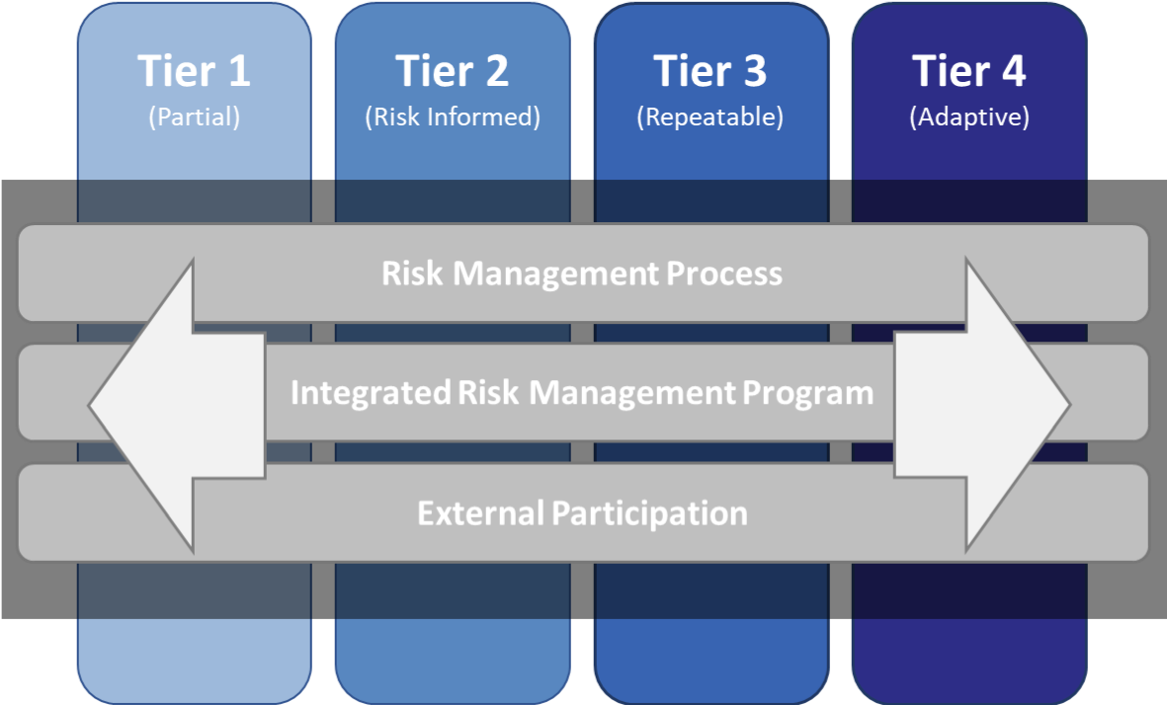
nist.gov
metricstream.com
Current: Tier 2 overall.

7. Prioritized Recommendations & Roadmap
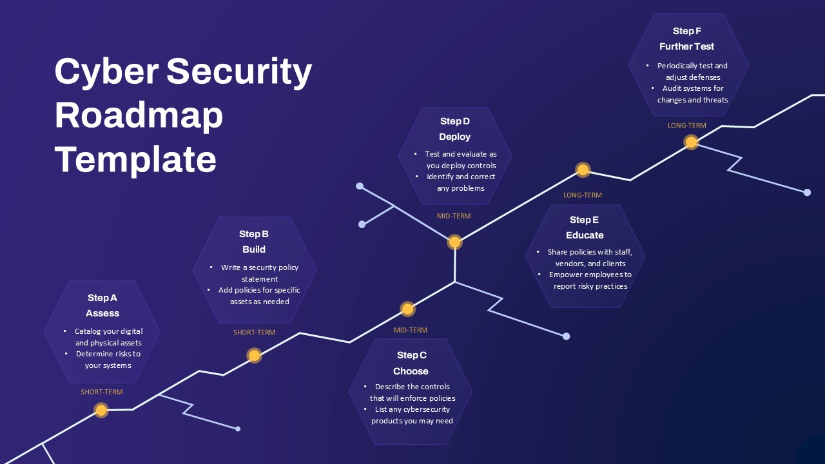
slidekit.com
Cyber Security Roadmap Template for PowerPoint & Google Slides
Priority | Recommendation | NIST Ref | Timeline | Owner
High | Document incident response plan | RS.PL-01 | 0-3 months | CISO
High | Define roles/responsibilities | GV.RR-01 | 0-3 months | Leadership
... | (20+ detailed rows) | ... | ... | ...

8. Conclusion
Solid foundation in assets and leadership, but operational gaps increase risk. Implement recommendations to reach Tier 3.

Appendix A: Full Assessment Questions & Responses
(Table with all ~100 questions, responses, scores, comments – adds 8-10 pages.)

Appendix B: References
- NIST CSF 2.0 (NIST CSWP 29)
- Quick Start Guides, etc.

